Data Representation: ASCII & Unicode
im_ascii.php — Information Management

Data Storage - ASCII, Unicode, etc.

Representing Letters / Characters
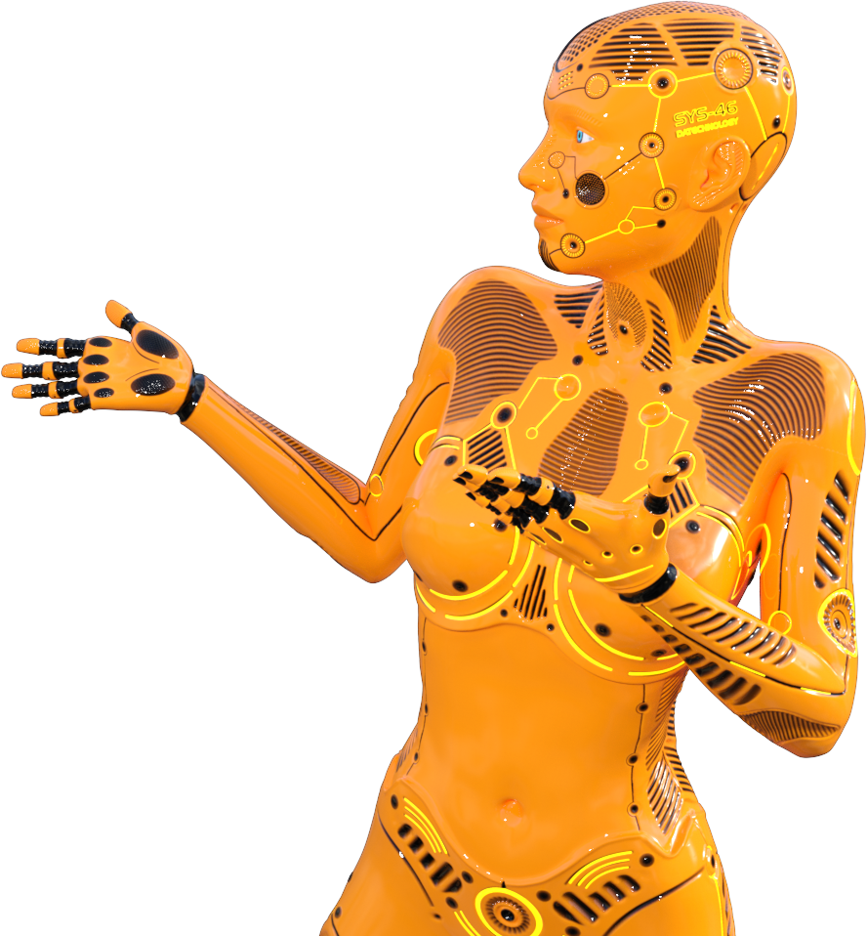
At the start of the chapter you should have learnt that computers use tables of numerical codes to represent letters of the alphabet or any other text characters.
There are many such tables but we are only going to focus on two in specific, namely ASCII and Unicode.
ASCII
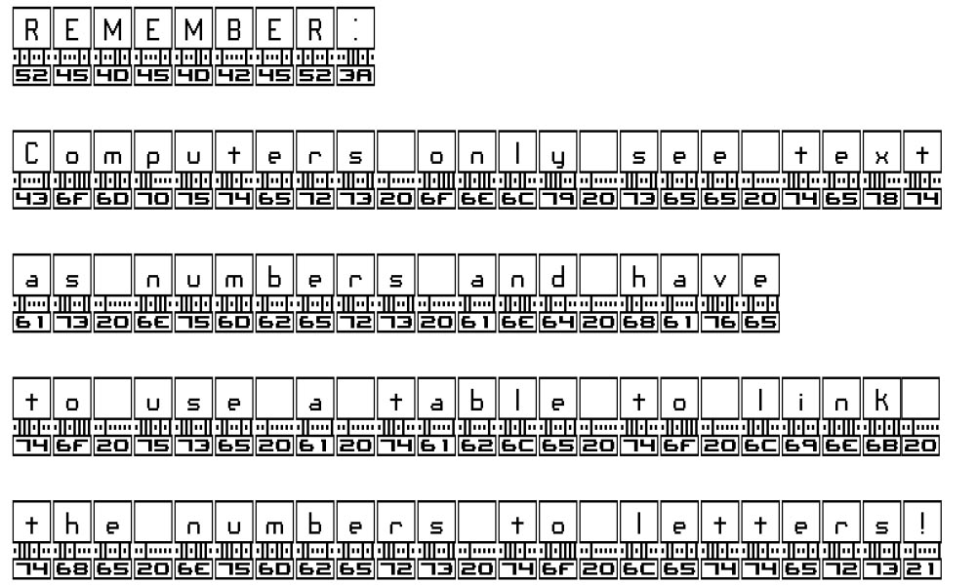
The picture says it all. Underneath each letter is its binary value - and underneath that is its Hexadecimal value. Remember that it takes two hexadecimal digits to represent a byte, so each letter will always have a two digit Hex value.
ASCII stands for American Standard Code for Information Interchange.
The original shorter version of the ASCII table and the longer version are both shown below.
As you can see, the first codes in ASCII are actually computer (and printer and communications) control codes.
ASCII later expanded to 256 characters (8 bits or a byte). This allowed some extra characters and text based graphics.
ASCII was the default character for the english speaking world for a long time.
Obviously it does not do well in supporting European languages with accents and other symbols. Russian (i.e. Cyrillic), Chines, Japanese, Arabic and other languages with different symbols are not supported at all.

536F202E736F20676F6F6421
(thats what a sentence looks like to a computer - translate it for yourself!)
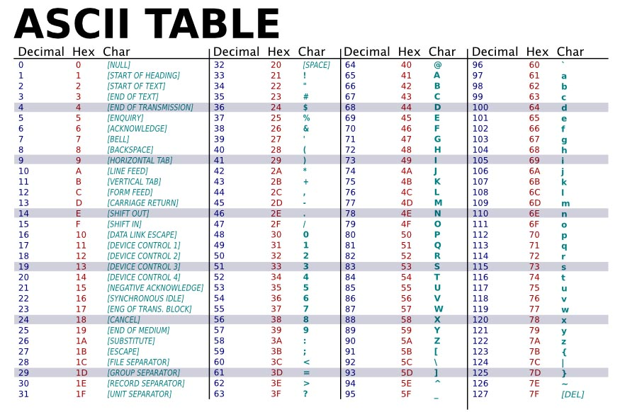
The table shown above is the original ASCII table with 127 characters (i.e. a 7 bit number).
The table below is the extended ASCII table that allows some characters with diacriticals (the accents, etc) and some text graphics.
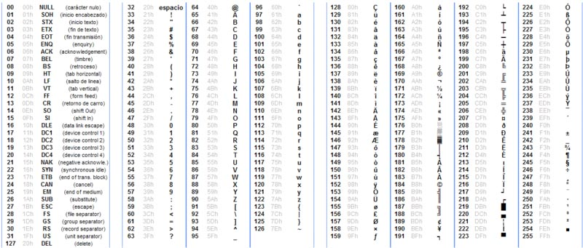
Back to the top of this panel
Unicode
Unicode is a much longer, more comprehensive table of characters that can hold symbols in all languages - as well have space for standardised emojis!
The most commonly used form of Unicode is UTF 8 which is the standard used on the WWW.
English speakers are lucky because Unicode keeps the same characters for letters of the English alphabet as ASCII used.
We are not even going to try to show a table of Unicode characters - it would be just too long!
[image unavailable: the_history_of_unicode.png]
Cartoon from XKCD - A webcomic of romance,
sarcasm, math, and language - created by Randall Munroe
Back to the top of this panel

Video Links - Data Storage (bits, bytes, ASCII, etc)
We have selected and curated a set of videos on YouTube related to your course.
These videos are not created or owned by us.
They may display advertising and in some cases may contain limited amounts of swearing.

Notes for this Module
What to look out for and do in this module...

FAQs for this module
Questions on ASCII / Unicode - and their answers...

Network Types FAQ
View the questions or type in the term you are looking for below…
No results were found

Why is it so important to understand ASCII?
The fact that letters are represented by numbers is why we can sort words using computers - and why sometimes you get weird results (all Upper Case letters have lower number values and so 'Zebra' will come before 'apple' when sorted on a computer.
This also allows comparisons such as converting between lower and uppercase (just add or subtract 32), checking if words are greater or less than each other, etc.
It also helps you understand that computers work on an abstact level - they don't know, care about or understand the data they are working on - it's all just a sequence of on / off switches to them.

What is used today - ASCII or Unicode?
It depends on the software you are using - but generally Unicode.
When it comes to characters in the Western Alphabet is does not make too much difference because an 'A' in ASCII has the same value as an 'A" in Unicode.

